ECCS 1611 – Programming 1

PreLab 5 – **Programming practice with iteration with your group!  
Dominic Hupp**

Please write the following programs using Visual Studio or Xcode. When completed, please submit your .cpp file to Moodle.

**Pre5.1** Write a program that reads an integer *n*, with *n* ≥ 3, indicating the length of a side and displays, using asterisks, a ﬁlled and hollow square, placed next to each other. For loops must be used to solve the problem. **For hints please refer to Table 3 in Section 4.8 of your textbook**.

Example run (with user input indicated with ***bold italics***):

Enter number of asterisks per side: ***5***

***** *****

***** * *

***** * *

***** * *

***** *****

**Pre5.2** Write a program that approximates the value of pi as detailed below. **There is no input for this program**. For the output, set the precision to 13 (i.e., use the setprecision method). This technique is known as **Gregory–Leibniz series.**

Hints and Help:

* Chapter 4 Interactive Review Practice Problem #7
* Great slides with explanation: <http://www.w3codingschool.com/0_sjcc/week3/C++ComputePI.pdf>

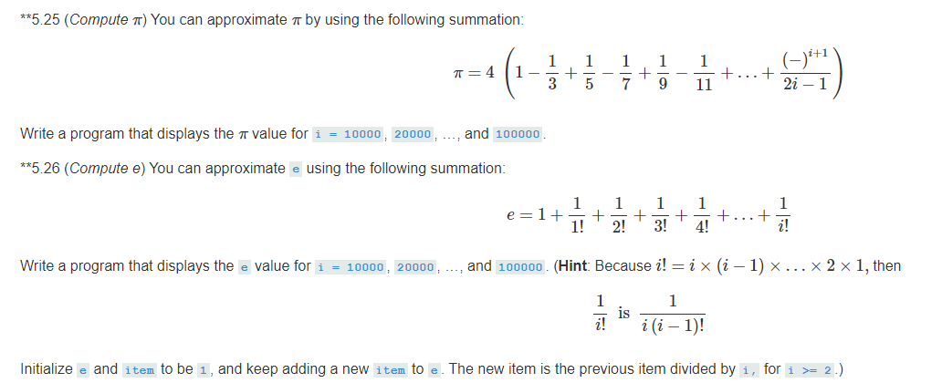

**Test Run (no user input):**

Reminder: Does your program show outputs shown from 10,000 to 100,000 in increments of 10,000?

Write down the value of pi for i = 100,000 (i.e., the last one): 3.1416026536897